Memo

|  |  |  |  |  |  |
| --- | --- | --- | --- | --- | --- |
| **To:** | Louise Grondin  Michel Julien | **Division: Environment** | |  | |
| **From:** | Chris Kennedy  Jean Cayouette  Maurice Houle | **Project:** | All | |
| **Cc:** | Josée Noel  David Paquin | **Date:** | March 27, 2018 | |
| **Subject:** | Recommendation to add multi-element scans to exploration drill core geochemical analyses – DRAFT | | | |

# Introduction

Drill core is essential for any mining exploration program and its characterization provides the information required to define a geological resource. Pending the type of characterization performed, drill core can also be used as part of environmental studies, including geochemical risk identification and management, even at the onset of resource delineation by the exploration geology team.

A common approach taken in the mining industry is to include multi-element analyses of drill core at the onset of an exploration program even before a resource has been identified. However, the current understanding is that Agnico Eagle primarily assays only for gold, with the occasional addition of silver and other metals such as copper. If the current approach was changed to include multi-element analyses, there are many opportunities that could ultimately help Agnico Eagle lower environmental risk at all stages of a mining project (i.e. exploration to post-closure), enhance geometallurgy programs, and possibly identify additional resource opportunities.

This memo provides justification for changing AEMs current geochemical practice for drill core to include multi-element analyses for all future AEM exploration programs. Justification provided herein is based on:

* Advantages for environmental assessment programs;
* Advantages for exploration geology and mineral processing;
* Opportunity costs at Agnico Eagle;
* Relatively low cost; and
* Industry best practice.

Each of the above justification topics, as well as general guidance on sampling frequency, are discussed in the following sections.

# Environmental Assessment Programs

## Program Objectives

Environmental assessment programs are focused on identifying impacts during and post operations of a mine site. Geochemical risks are likely one of the most significant concerns owing to the volume of material produced (i.e. 99.9% of rock processed is non-economic in even the best gold deposit) and the frequent long term nature of reactivity. For example, the Eagle/Telbel (i.e. Joutel) tailings facility produced neutral drainage for two decades but is now producing acid rock drainage (ARD).

## Opportunities

Establishing geochemical reactivity (and also the geometallurgy) of an ore deposit is often based on hundreds of samples, not the 10,000s of samples that typically are used in defining the economic basis of an ore deposit. This results in significant uncertainty risk and waste rock management decisions either end up being overly conservative, too onerous for the site to manage during operations, or are missed completely. All of these scenarios potentially have impacts of several millions of dollars over the life of a mine.

The existing uncertainty is typically addressed by regulators and stakeholders through significant financial assurance (i.e. bonding requirements). The inclusion of multi-element data in drill core at the same frequency as gold assays offers an opportunity to dramatically reduce uncertainty risk (and therefore potential mitigation costs) as a result of the following:

* High resolution understanding of rock composition throughout the deposit – both in ore (for tailings), waste rock, pit walls, and borrow sources
* Potential to model non-economic rock (i.e. waste rock) reactivity for the entire deposit before it is mined – this is industry leading and far more efficient for planning waste handling as compared to waiting to analyse blast hole cuttings during operations and then deciding how to manage the rock
* Better confidence in mine planning, such as getting the most accurate understanding possible on how much material may need to be segregated or managed to mitigate long term closure liabilities. The current practice of designing rock and tailings storage facilities based on tens to maybe hundreds of samples is high risk
* Identification of non-reactive borrow materials within the waste rock zone around the ore deposit and elimination of the need to quarry for borrow material in some projects.
* Metal leaching assessment – the inclusion of multi-elements would allow for an immediate assessment of metal leaching risks. Even at the scoping level stage of project development, it could be assessed whether there is leaching risk of a given element that may require a water treatment plant to treat or require a change to the mine plan to mitigate the leaching process. Pending the type of element leaching risk, water treatment costs can easily approach $100M for CAPEX and $50M per year for OPEX.

There would still need to be detailed geochemical study on small subset of samples to properly correlate sulphide and carbonate reactivity to drill core geochemistry. However, once those correlations have been established, the combination with multi-element data throughout the deposit results in an industry leading approach to managing mine waste rock environmental risk. Two examples are provided in the next section.

## Examples

### Northern Ontario Open Pit Gold Mine

As part of project development studies for an open pit gold mine in northern Ontario, an ARD block model was developed for the deposit using multi-elements from exploration drill core. Detailed geochemical characterization testing prior to the block model established the following:

* ICP-MS sulphur analyses in exploration core were statistically correlated to sulphide sulphur (therefore ICP-MS sulphur was a suitable proxy for sulphide reactivity)
* ICP-MS calcium, magnesium, sodium, and potassium analyses in exploration core could be correlated to carbonate content (neutralization potential) using a regression equation. A regression was required to remove the contribution of the silicate associated calcium and magnesium from what was present in the carbonates.

Illustrations of the block model are provided in a three dimensional view (Figure 1) and cross-section through the pit (Figure 2). The high resolution understanding of waste rock ARD potential in terms of spatial and temporal locations (i.e. when it would be mined) in the pit provides a significant advantage to operations in terms of management timing, blending opportunities and facility design. The modeling also showed that previous testing had likely biased the amount of ARD proportion too high, resulting in higher than necessary closure cost estimates.

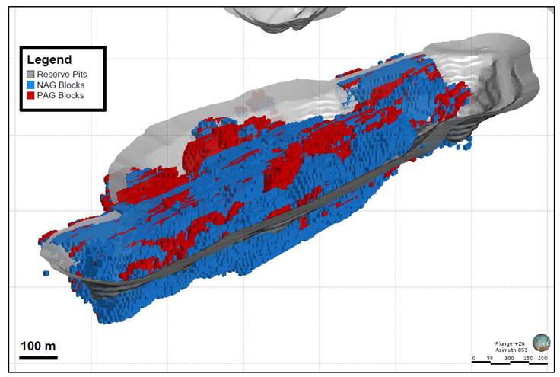

Figure : Three dimensional illustration of ARD PAG and NAG mine waste blocks.

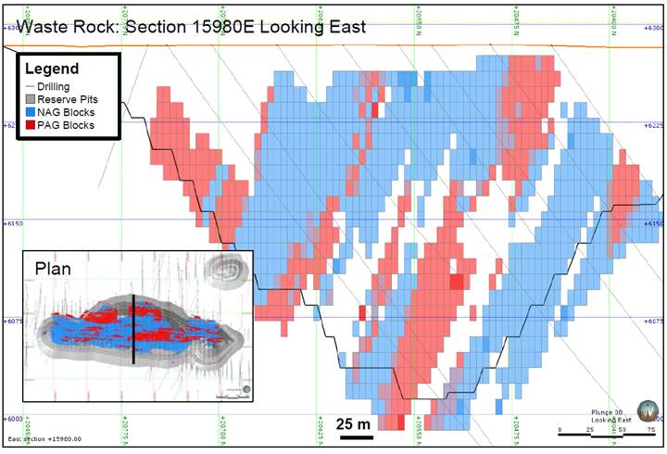

Figure : Cross section of potential pit showing ARD distribution.

Note: unshaded zones represent ore.

### Akasaba West

The Akasaba West project is located in the Abitibi, approximately 23 km to the east of AEMs Goldex Mine. Currently the project is in permitting with a geochemical characterization program completed. The main finding of the program was that there will be upwards of 50% PAG rock, with the current plan to manage waste rock south of the ore body as PAG, and north of the ore body as non-PAG. The amount of PAG rock may be over-estimated in the south zone, or perhaps underestimated in the north zone, but the current database is not sufficient to better define the ARD management opportunity and risk for the project.

A multi-element database would likely be able to quickly (i.e. days) resolve the following:

* The estimated PAG proportions – this is important as it impacts closure costs and long term liabilities. For example, the current plan is to place a cover over the PAG rock to limit sulphide oxidation, but this is unproven on waste rock and the best approach is re-handling back into the pit and water submergence. Re-handling is high cost (the reason this method was not chosen), but with the potential to reduce PAG rock by upwards of 30%, the best environmental approach may become an economically favourable one.
* Confirm whether the north zone is truly all non-PAG. If PAG zones are placed in a pile they can develop as hot spots and will dominate the overall drainage of a pile. Having an ARD model for the waste would allow for an evaluation of this risk.

# Exploration Geology and Mineral Processing

## Program Objectives

Drill core is a necessity to define any mineral resource and the effort and cost is significant. It is logged by geologists to construct a geological model of mineral deposit, including identification of economic minerals (i.e. pyrite, chalcopyrite, native gold, etc), other features such as alteration, fractures, faults, etc, and it is also submitted for chemical analyses to delineate the economic boundaries of the deposit and ultimately the amount of mineral that can potentially be extracted. Typically a sub-set of drill core from the ore zone is submitted for metallurgical testing to establish and optimize mineral processing.

## Opportunities

Three opportunities that could be realized by including multi-element analyses of drill core include:

* Pathfinding (both gold or other economically valuable deposits)
* Resolving uncertainty in drill core logging results
* Mineral processing or geometallurgy

Trace elements are a necessity for exploration geochemistry programs. The geochemical characteristics of rock near a potential resource often lead exploration teams to locate economic mineral deposits, which may not be readily identifiable through visual or other mapping programs. In addition, many mineral deposits being mined today were likely the target of a different commodity. For example, programs looking for gold have discovered copper or other base metal deposits. If drill core only includes an assay for gold the potential to discover other commodities is likely much lower. Of course mineral identification during logging may help provide clues to other economic deposits (e.g. the presence of chalcopyrite), but the extent and opportunity is likely lost if multi-elements are not included in the analysis.

Geological logging is a powerful tool that is relied upon to construct geological models of deposits and has been used to defend the exclusion of analysis for multi-element data in drill core scans. However, one of the biggest problems in generating realistic geological and alteration models is the lack of consistency in the logging data. Mine site drill hole data bases typically contain logging data collected over a period of many years. In most cases the logging will have been completed by tens of different geologists with varying amounts of competence and experience. Consistent logging requires a significant level of skill, but this task is generally assigned to the most junior geologists. As a result, there is a large degree of subjectivity in the recognition of basic rock types, and an even greater lack of consistency in correctly identifying alteration mineralogy, particularly when it involves logging RC chips (e.g. exploration programs in highly weathered environments like Mexico or South America).

Geometallurgy combines geology with extractive metallurgy to create a spatially or geologically based predictive model for mineral processing. As mineral recovery is dependent on the physical and chemical characteristics of the ore, only having a small sub-set of samples to develop the predictive model can result in economic risk in terms of poor recovery. Inclusion of multi-elements in drill core at the same frequency as gold assays has the ability to provide a much higher resolution of geometallurgy characteristics, and can also help identify the presence of deleterious or interfering elements to gold recovery processing. A summary of opportunity costs at Agnico Eagle are provided in Section 4.

## Drill Core Logging Case Studies

Two case studies that illustrate the advantage of including multi-element data in drill core are extensively described in a paper by S. Halley Consulting geochemist at Mineral Mapping Pty Ltd. (summarized in Attachment A). The first example in his paper uses the Copler Gold deposit in Turkey to demonstrate how mutli-element data was able to quantity alteration that was not possible through geological logging. The second example in the paper was from the Haquira Porphyry-Cu deposit in Peru which employed partial digest ICP data to classify and model different types of Cu mineralogy.

# Opportunity Costs at Agnico Eagle

There are a number of examples over the history of Agnico Eagle where having multi-element data could have resulted in significant (i.e. > $10M) cost savings for specific projects in terms of lost revenue. Some of these cost implications have been summarized by the geometallurgy group at Agnico Eagle and are provided in Figure 3.

Historically, there may have been some technological restrictions and prohibitive costs to including multi-element scans on drill core. However, at present day, the necessary analytical instruments are routine in commercial laboratories that Agnico Eagle uses for gold assay and the respective costs have decreased dramatically. Estimated analytical costs are provided in Section 5.

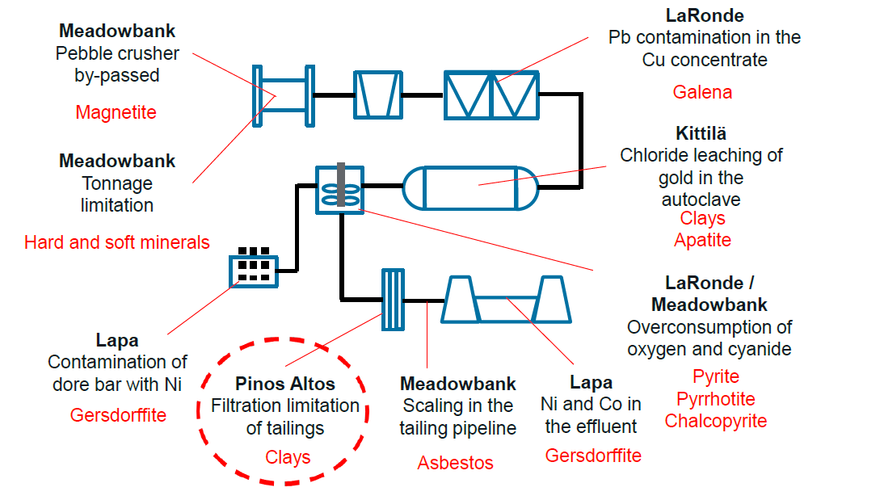

Figure : Process flow diagram with geochemical and mineralogical characteristics that led to revenue loss at Agnico Eagle operations.

# Analytical Costs

The estimated cost to include multi-element scans on drill core samples already being submitted for gold assay is $6.33 per sample. This is based on a discussion with ALS Minerals in Val d’Or and would include aqua regia digestion and analysis of 43 elements, including sulphur (ALS code ME-ICP-41). As a basis for comparison, the approximate cost for a gold assay is ~$13/sample, which includes sample preparation from drill core. For instances where an element is being determined through ICP-MS (e.g. silver or copper), the data for all other multi-elements has actually already been collected by the analytical instrument and simply requires data interrogation by a software program to be reported. The cost was not provided in this case, but would likely be only on the order of a few additional dollars per sample given no additional analysis on the ICP-MS would be required.

When considering the cost for drilling, logging, and sample handling to acquire the gold assay, the additional cost is relatively minor compared to the costs of a drilling program. In 2018, Agnico Eagle’s global exploration budget was estimated at $100 M, with approximately 300,000 samples. At a cost of $6.33/sample, this is only 1.9% of the budget ($1.9M), which is less than a typical project contingency. More importantly, this cost should be considered an investment as ultimately it is expected to result in cost savings that are magnitudes greater than the investment.

# Industry Best Practice

The majority of other mining companies, from juniors to senior producers, are including multi-element analyses of their drill core. This is based on experience of employees at Agnico Eagle that were previously consultants to other mining companies and our internal evaluations team.

Nearly every project database the evaluations team reviews (conservatively estimated to be greater than 90%) includes multi-element analyses on every drill hole. Many of the projects reviewed have block models developed for non-gold parameters such as copper, arsenic and sulphur. In instances where the models do not exist, the evaluations team will often generate block models for deleterious elements like arsenic, sulphur and selenium.

# Sampling and Archiving Recommendations

Sampling frequency and archiving drill core for multi-element analyses should be based on the project stage:

* **Early exploration/pre-resource** – if multi-elements are not needed for prospecting, archive sample pulps used for gold assay for potential analysis of multi-elements at a later date. Ensure analytical laboratory is aware of potential long-term storage requirement so that pulp samples are not inadvertently disposed.
* **Resource definition activities**
  + Waste – if rock has the potential to be excavated (open pit or underground), it should be sampled and analysed. Typically a composite sample is taken every 1.5 to 3.0 metres, which would be sufficient, but will vary depending on the geological setting and understanding of the deposit. The sampling frequency should also be discussed with the resource geologist for the project to determine the sampling frequency needed to develop a block model.
  + Ore – all samples submitted for gold are to be submitted for multi-elements. Ore resource definition will benefit, as will geometallurgy and environment studies (e.g. ore characteristics leading to tailings reactivity assessment).
* **Feasibility studies/in-fill drilling**
  + Sampling and analysis should be the same as in resource definition activities described above for waste rock and ore.

# Closing

Environmental and geological programs (i.e. exploration and geometallurgy) within Agnico Eagle would benefit significantly from the inclusion of multi-element scans. For a relatively small cost increase, additional gold or other commodity resources could be identified, mineral processing risks reduced (or optimized), and environmental risks and costs could likely be lowered in amounts far exceeding the additional costs.

Attachment A: Multi-Element Benefits to Resource Geology Case Studies